Exp.No:4AnalysisofContinuousChargeDistributioninelectricfield.Tofindthe(i) linechargedensity,(ii)Surfacechargedensityand(iii)Volumechargedensityforany specific(a) line, (b) surface or (c) volume.
Date:
Aim:TowriteprogramforcontinuousCharge Distribution inelectricfield. Thedifferent typesofchargedensitythereare(a)LinearChargeDensity,(b)SurfaceChargeDensity,
(c)VolumeChargeDensityusingSCILAB.

Software required:
- SCILAB version6.0.1
Theory: Program:
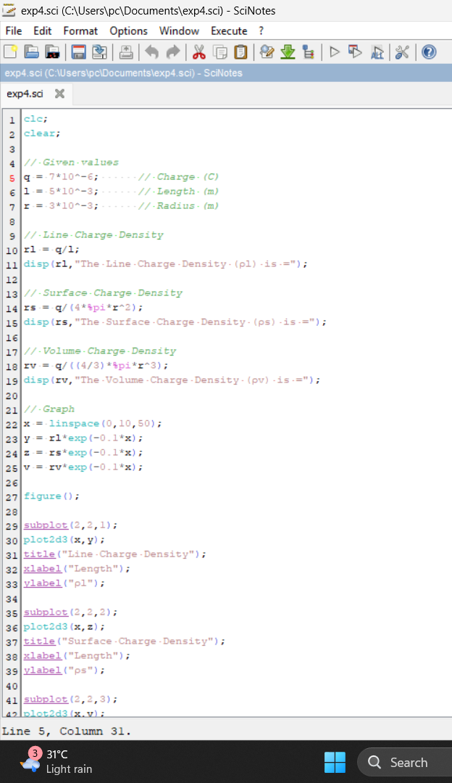

Output:
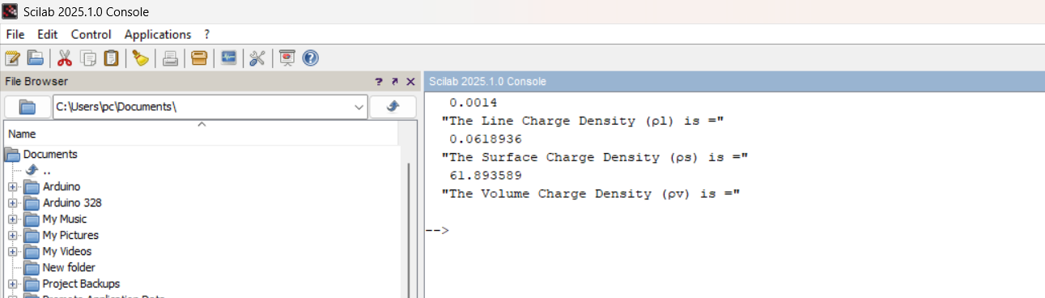

Calculation:

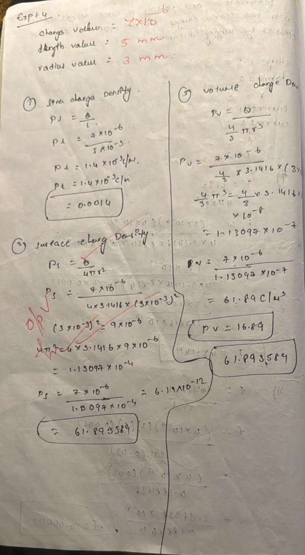

Case2:
A long wire of length L=10m carries a uniform charge of Ǫ=50μC. The goal is to calculate the line charge density λ and determine how the electricfield behaves as a function of distance from the wire.
Program:

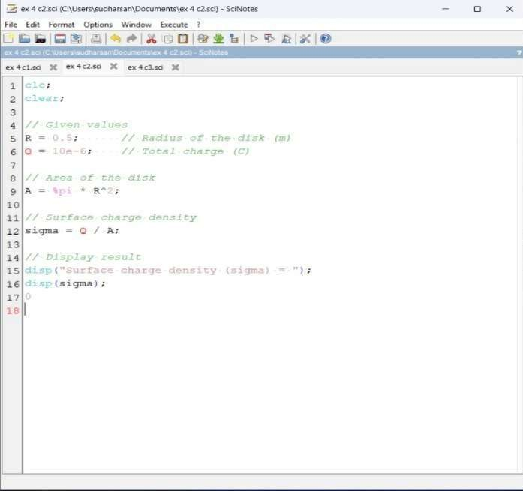

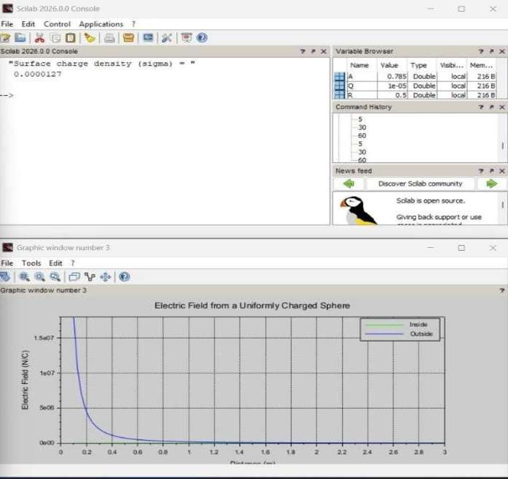

Calcution:
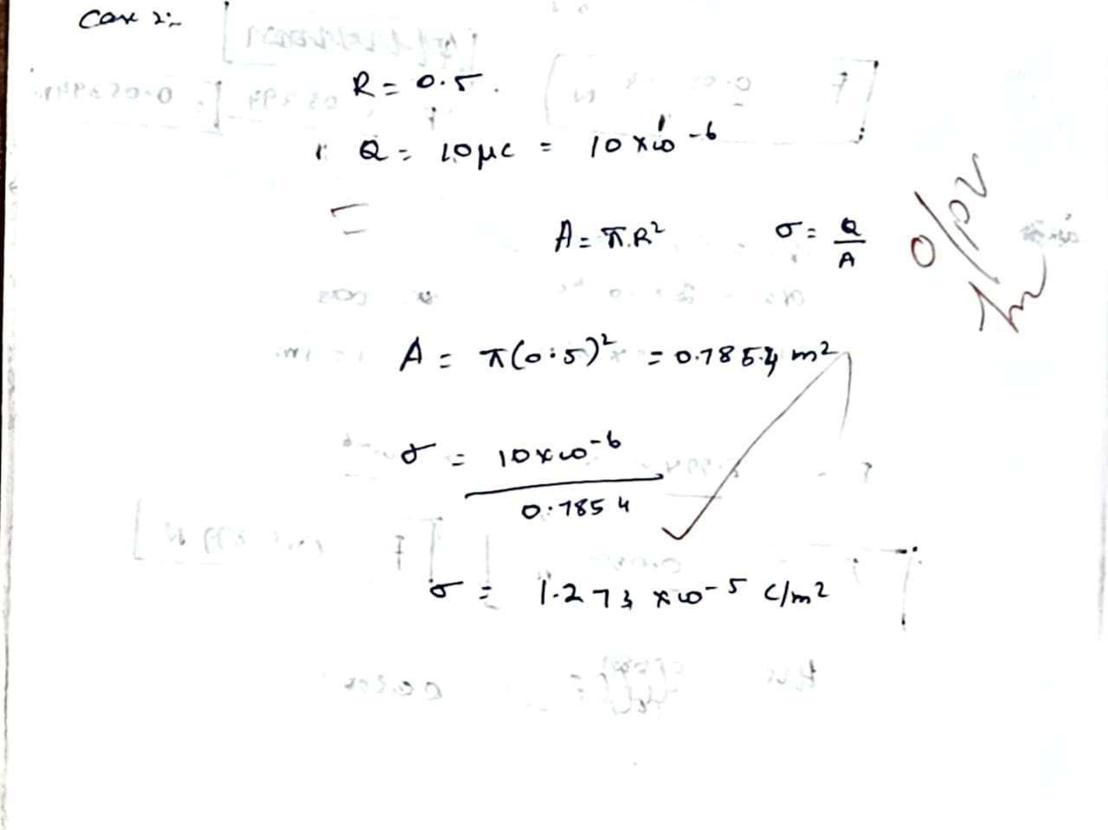
Case3:

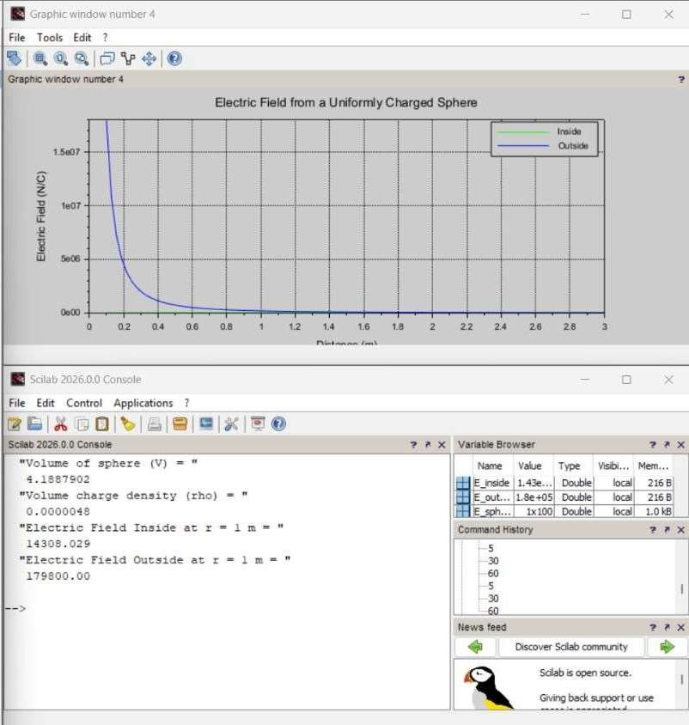
Given a uniformly charged disk of radius R=0.5m with total charge Ǫ=10μC, calculatethesurfacechargedensityandplottheelectricfieldalongtheaxisofthe disk.Explainthebehavioroftheelectricfieldasafunctionofdistancefromthe center of the disk.
Program:
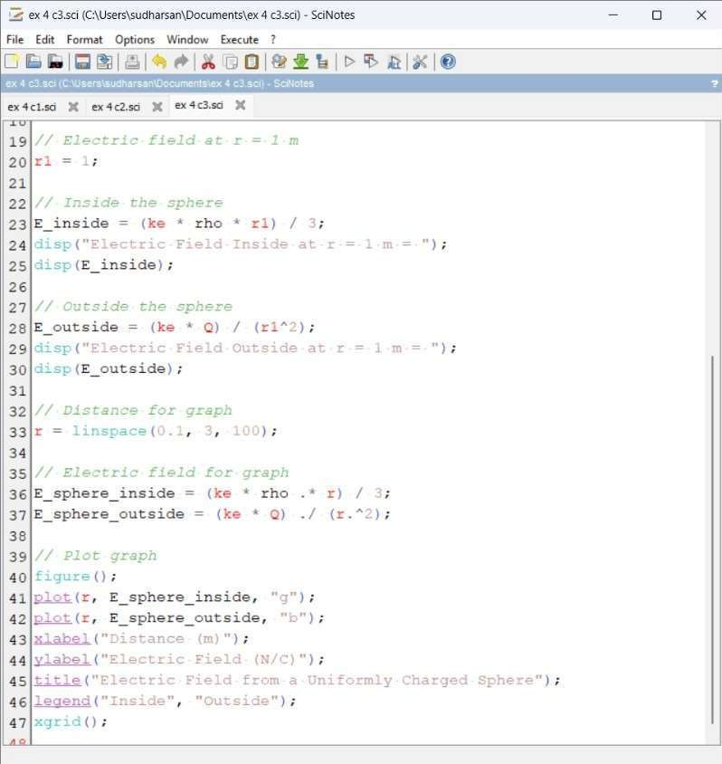
Output:

Calcution:

